Department of Languages, Literatures and Cultures
Technology Workshop:

New Resources for Language Teaching & Learning

Luba Iskold,
Director, Language Learning Center

- New Software: TextAloud & VoiceThread

- Departmental Website Updates

- Student-Led Workshop Series

- LLC Information & Schedules

- Course Packages with Online Materials

Useful URLs:

• Department of Languages, Literatures and Cultures
http://www.muhlenberg.edu/main/academics/llc/learning_center/index.html
• Language Learning Center: http://www.muhlenberg.edu/main/academics/llc/learning_center/index.html
• Online Resources:
http://www.muhlenberg.edu/main/academics/llc/web_resources/
http://www.muhlenberg.edu/main/academics/llc/learning_center/update/web_resources.html
• Campus Resources: http://www.muhlenberg.edu/main/academics/llc/facilities/index.html
• Dish TV & SCOLA:
http://www.muhlenberg.edu/main/academics/llc/learning_center/international_tv.html
• Study Abroad: http://www.muhlenberg.edu/main/academics/llc/study_abroad_main.html
• News & Events: http://www.muhlenberg.edu/main/academics/llc/news_events/
• Language Clubs: http://www.muhlenberg.edu/main/academics/llc/clubs/
• Alumni: http://www.muhlenberg.edu/main/academics/llc/alumni/index.html
• Kalliope:http://www.muhlenberg.edu/main/academics/llc/Kalliope/KalliopeHome.html
• Arabic: http://www.muhlenberg.edu/main/academics/llc/program/arabic/
• Chinese: http://www.muhlenberg.edu/main/academics/llc/program/chinese/
• French: http://www.muhlenberg.edu/main/academics/llc/program/french/
• German: http://www.muhlenberg.edu/main/academics/llc/program/german/
• Hebrew: http://www.muhlenberg.edu/main/academics/llc/program/hebrew/
• Russian: http://www.muhlenberg.edu/main/academics/llc/program/russian/
• Spanish: http://www.muhlenberg.edu/main/academics/llc/program/spanish/

What is TextAloud? How can Students use this Program?
http://www.nextup.com/?gclid=CKG6lafm_LECFYNM4AodxCYAvA

TextAloud is Text to Speech software for Windows that converts text from MS Word Documents, Emails, Web Pages and PDF files into natural-sounding speech. You can listen on your PC or create audio files for use on iPods, iPhones, and other portable devices. TextAloud even has automatic iTunes syncing.

Students can:
- practice listening and pronunciation outside the classroom
- prepare for presentations, speeches, oral exams
- study regional variations
- get additional help if they have special needs

TextAloud is available on 5 PCs (4-8):
- One Arabic voice, Leila, recommended by Mirna - PC 8
- One French voice, Julie, recommended by Eileen - PCs 6-8
- One German voice, Klaus, recommended by Franz - PC 5
- One Italian voice, Vittorio, recommended by Santa - PCs 4-6
- One Russian voice, Alyona, recommended by Luba - PC 7
- Two Spanish voices, Rosa & Ines, recommended by Erika - PCs 4-8
- Examples of Text to Speech in French, Russian & Spanish prepared by Tiffany - PC 7
What is VoiceThread? How can Students use this Program?
http://voicethread.com/

VoiceThread is a collaborative, multimedia slide show that holds images, documents, and videos and allows people to navigate slides and leave comments in 5 ways:
• voice (with a mic or telephone) • text (type or upload a file) • audio file • video (via a webcam).

Students can:
- See/hear voice threads or assignments posted by instructors
- Share their own VoiceThread with instructors and peers
- Record and post comments in a variety of formats

Links to Online Tutorials:
https://voicethread.com/support/howto/Basics/
https://voicethread.com/?#q:

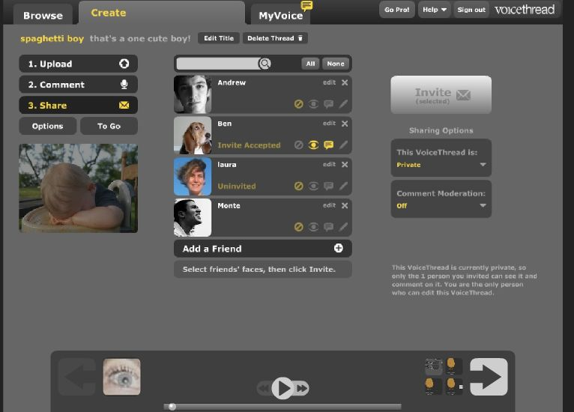

New on Departmental Website:

Virtual Gallery: International Drama Poster Exhibit
http://muhlenberg.edu/main/academics/llc/LLC_PosterExhibit/International_Drama.html

LLC Video
http://www.muhlenberg.edu/main/academics/llc/learning_center/

Why Learn a Language?
http://www.muhlenberg.edu/main/academics/llc/WhyLearnaLanguageLinks.html

Careers with Languages
http://www.muhlenberg.edu/careercenter/majors/pdf/foreign.pdf

Facebook Page for the Department (demo)

New Links by Language (recently recommended by the NYT)
Examples:
Learn the Language: http://www.learnalanguage.com/
Living Language: http://livinglanguage.com/
Digital Dialects: Games!: http://http://www.digitaldialects.com

Student-Led Workshop Series, 2012-2013:

- TextAloud (text to speech software)
- VoiceThread (multimedia, slides & discussion)
- iPad
- Kindle Fire
- Workshop for Language Tutors

Language Learning Center - Information & ALL Schedules (see below) are also posted here:
http://www.muhlenberg.edu/main/academics/llc/learning_center/index.html

- LLC Hours: M-TR 8:30 a.m.-9:00 p.m. F 8:30 a.m.- 4:00 p.m. Sat. & Sun. CLOSED
- LLC Class Visits Fall 2012 (Schedule TBA)
- Fulvia Alderiso, Lab Tech LLC: M-F 9:00 a.m. - 12:00 p.m. & 1:00 - 5:00 p.m.
- Tiffany Kreider, PA LLC: M/W 11 a.m. -12:30 p.m. & 2:00 - 4:00 p.m.
T/TR 8:30 a.m. - 11:00 a.m. & 1:00 - 4:00 p.m.
- Student Workers’ Schedules (TBA)
Emily Prawer '14 - Spanish, Hebrew (8 hrs.)
George Fuzayl '14 - Russian, Hebrew, Spanish (8 hrs.)
Karen Trakhtenberg '14 - Russian (6 hrs.)
Paul Kallen '14 - Chinese, Arabic, French (4 hrs.)
Colin Zelin '15 - Spanish (8 hrs.)
Chelsea Britten '15 - French, Spanish (8 hrs.)
Jordana Sklover '15 - Hebrew, French, Spanish (8 hrs.)
Kelsey McIntyre '16 - French, Spanish

